DHAKA UNIVERSITY OF ENGINEERING & TECHNOLOGY, GAZIPUR-1707

DEPARTMENT OF COMPUTER SCIENCE AND ENGINEERING



Course No: CSE 3812

Course Title: Microprocessor and Interfacing Sessional

**Assignment 1**

Date of Allocation: 10/11/2024

Date of Submission: 23/11/2024

**Submitted To:**

Dr. Md. Jakirul Islam

Associate Professor, Department of CSE

Dhaka University of Engineering & Technology, Gazipur

Sumaya Khatun

Lecturer, Department of CSE

Dhaka University of Engineering & Technology, Gazipur

**Submitted By:**

Name: Imran Raza

Student ID: 214097

Year/Semester: 3rd year / 1st Semester

Section: B

**Objectives:**

To understanding assembly language using EMU8086.

**Problem Statement:**

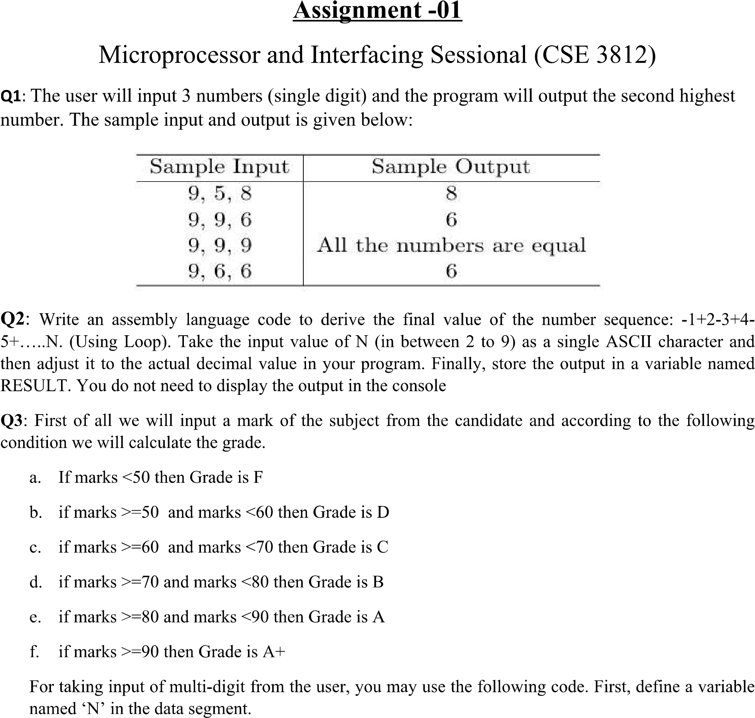

|  |  |
| --- | --- |
|  |  |

|  |  |
| --- | --- |
|  |  |

|  |  |
| --- | --- |
|  |  |

**Problem 1:**

ORG 0100H

.DATA

A DB ?

B DB ?

C DB ?

TEMP DB ?

SAME DB 'All the numbers are equal$'

COMMA DB ',$'

.CODE

MAIN PROC

MOV AX,@DATA

MOV DS,AX

;INPUT

MOV AH,1

INT 21H

MOV A,AL

MOV AH,9

LEA DX,COMMA

INT 21H

MOV AH,1

INT 21H

MOV B,AL

MOV AH,9

LEA DX,COMMA

INT 21H

MOV AH,1

INT 21H

MOV C,AL

;NEW LINE

MOV AH,2

MOV DL,0AH

INT 21H

MOV DL,0DH

INT 21H

;SORTING(DEC)

MOV AL,A

MOV BL,B

MOV CL,C

CMP AL,BL

JL SWAP1

JAMP1:

CMP AL,CL

JL SWAP2

JAMP2:

CMP BL,CL

JL SWAP3

JMP TERMINATE

SWAP1:

MOV TEMP,AL

MOV AL,BL

MOV BL,TEMP

JMP JAMP1

SWAP2:

MOV TEMP,AL

MOV AL,CL

MOV CL,TEMP

JMP JAMP2

SWAP3:

MOV TEMP,BL

MOV BL,CL

MOV CL,TEMP

;OVERWRITE

MOV A,AL

MOV B,BL

MOV C,CL

TERMINATE:

;CHECKING

CMP AL,BL

JZ EQUAL

MOV AH,2

MOV DL,BL

INT 21H

JMP RETURN

EQUAL:

CMP AL,CL

JZ OUT_MSG

MOV AH,2

MOV DL,CL

INT 21H

JMP RETURN

OUT_MSG:

MOV AH,9

LEA DX,SAME

INT 21H

RETURN:

MOV AX,4CH

INT 21H

MAIN ENDP

END MAIN

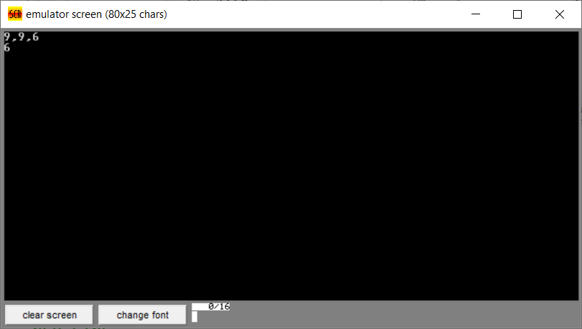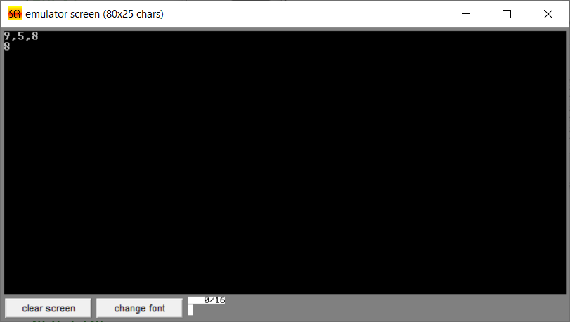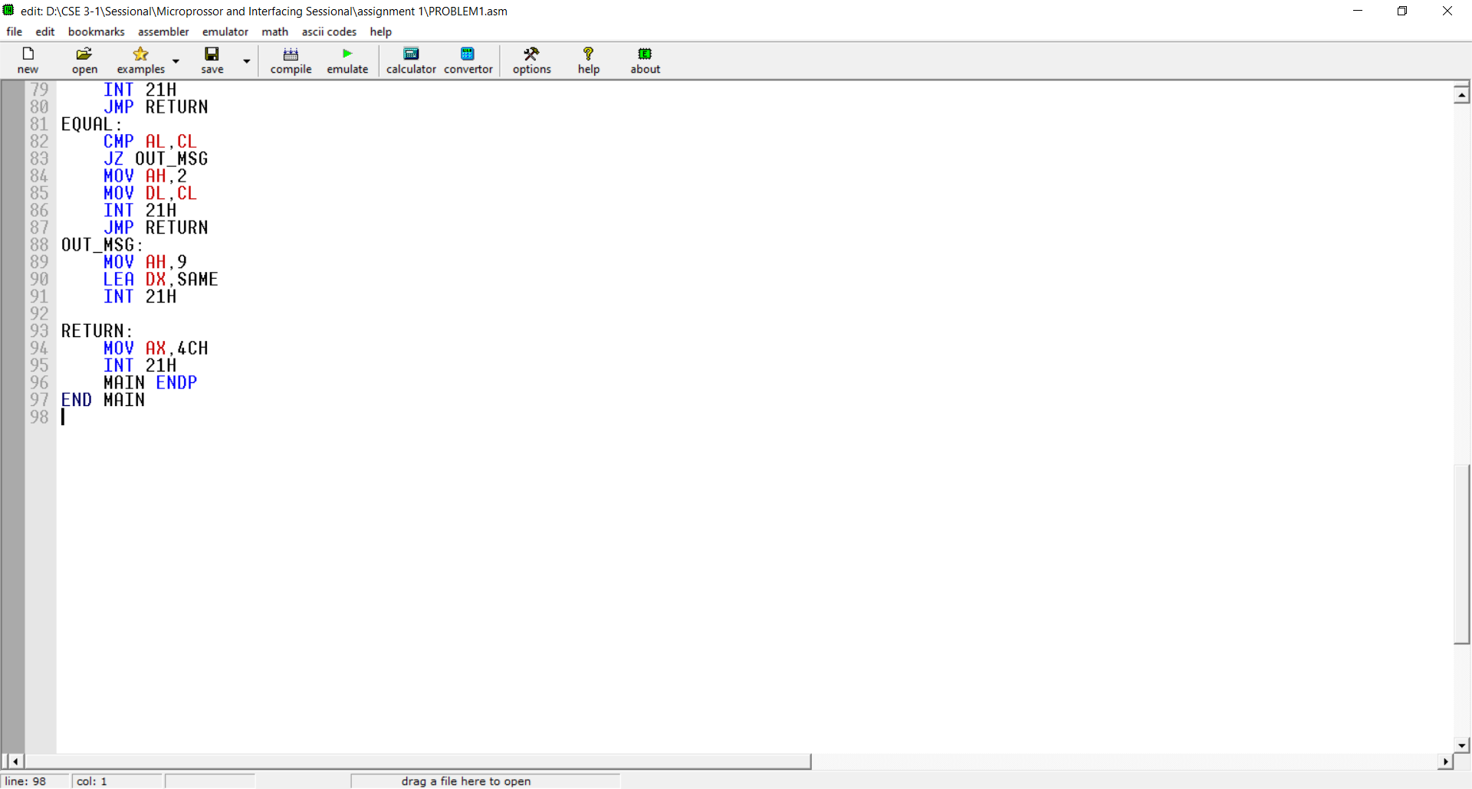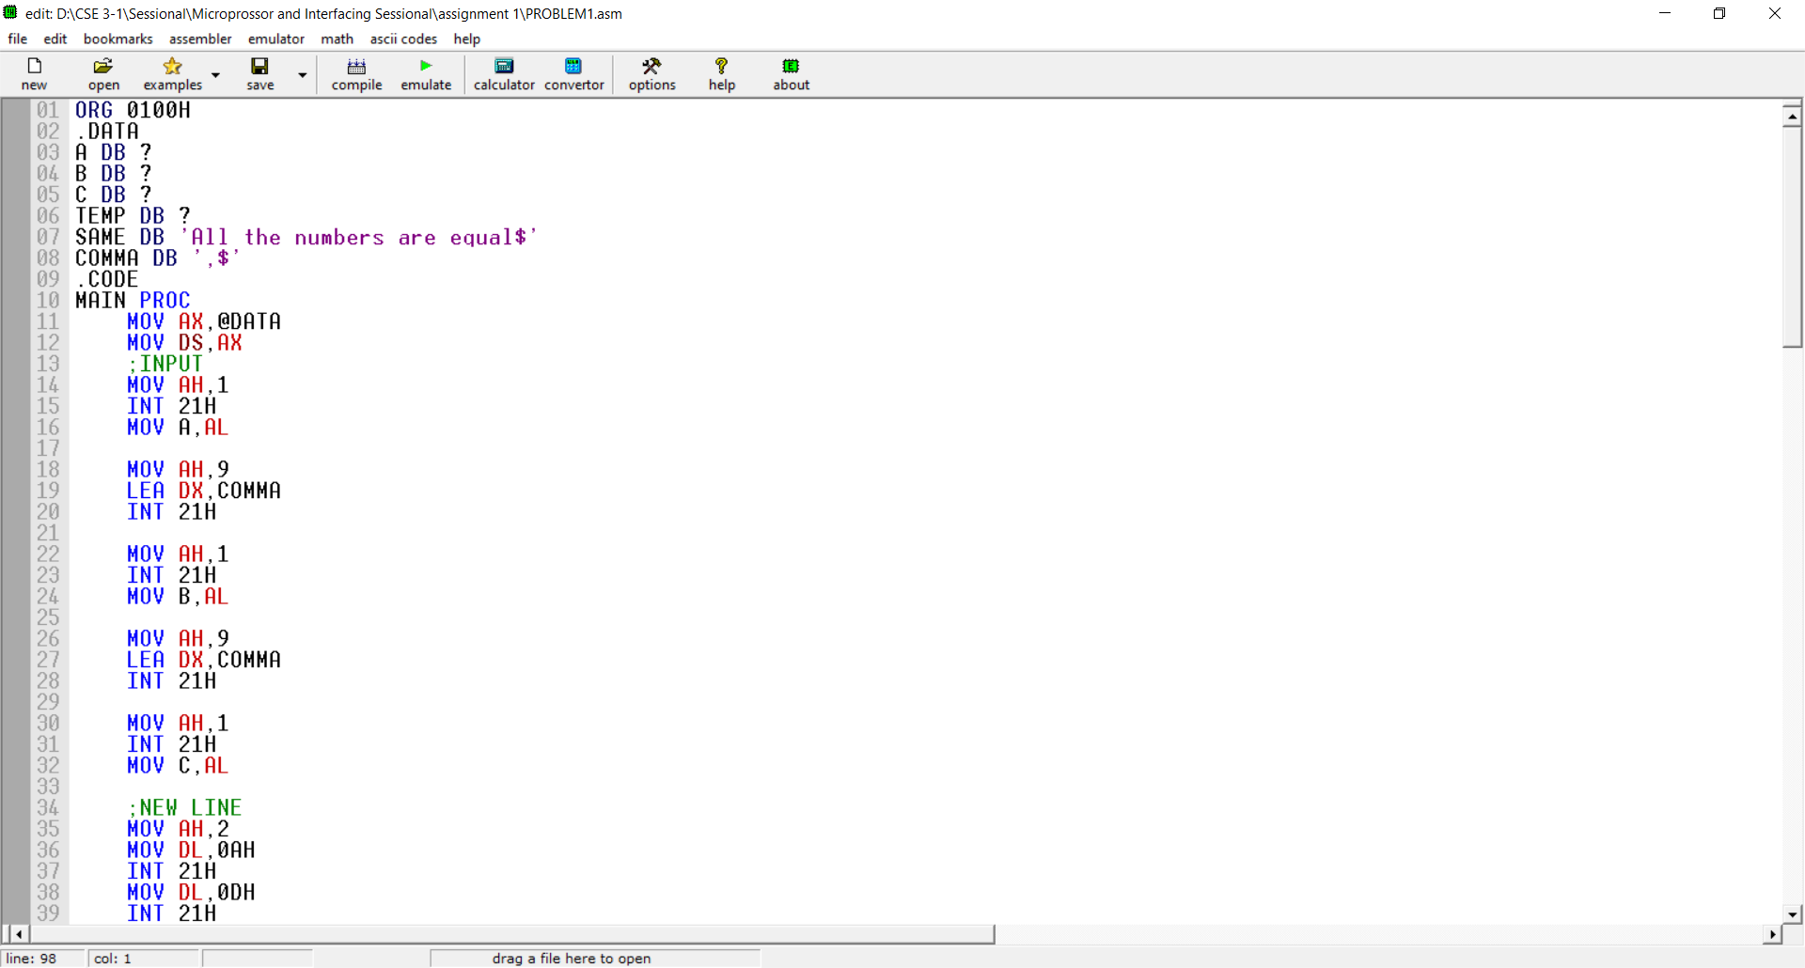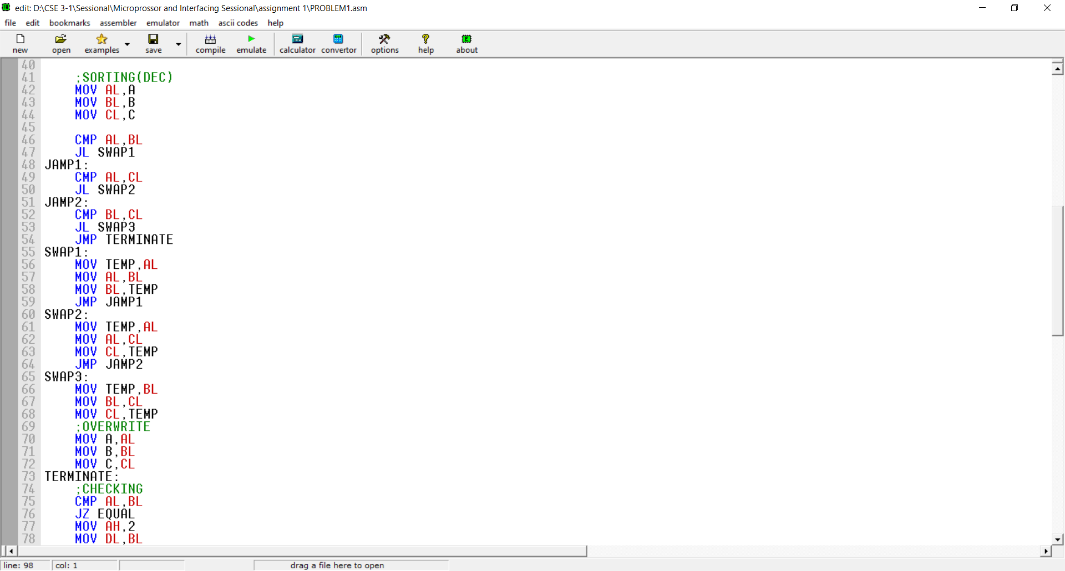

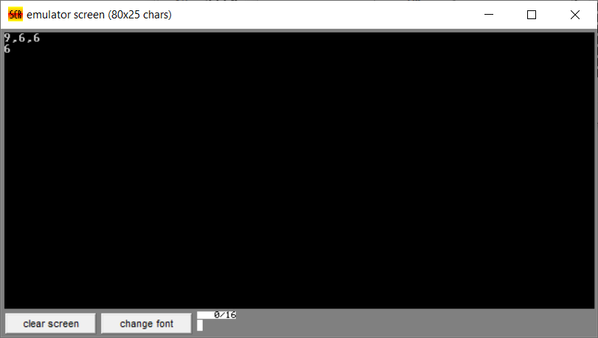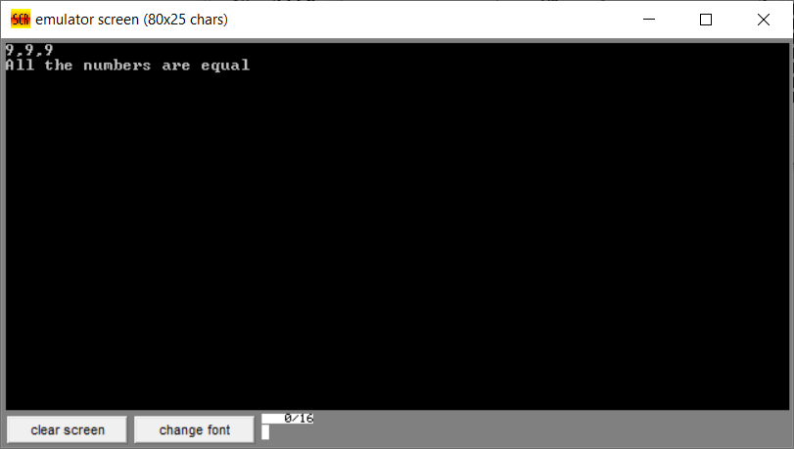

**Problem 2:**

ORG 0100H

.DATA

RESULT DB ?

N DB ?

SIGN DB ?

COPY DB ?

STR DB ?

.CODE

MAIN PROC

MOV AX,@DATA

MOV DS,AX

MOV AH,1

INT 21H

MOV N,AL

SUB N,48

MOV CL,N

MOV SIGN,-1

MOV COPY,-1

MOV STR,1

TOP:

MOV AL,STR

MUL SIGN

ADD RESULT,AL

MOV AL,STR

ADD AL,1

MOV STR,AL

MOV AL,SIGN

MUL COPY

MOV SIGN,AL

LOOP TOP

;RETURN:

MOV AX,4CH

INT 21H

MAIN ENDP

END MAIN

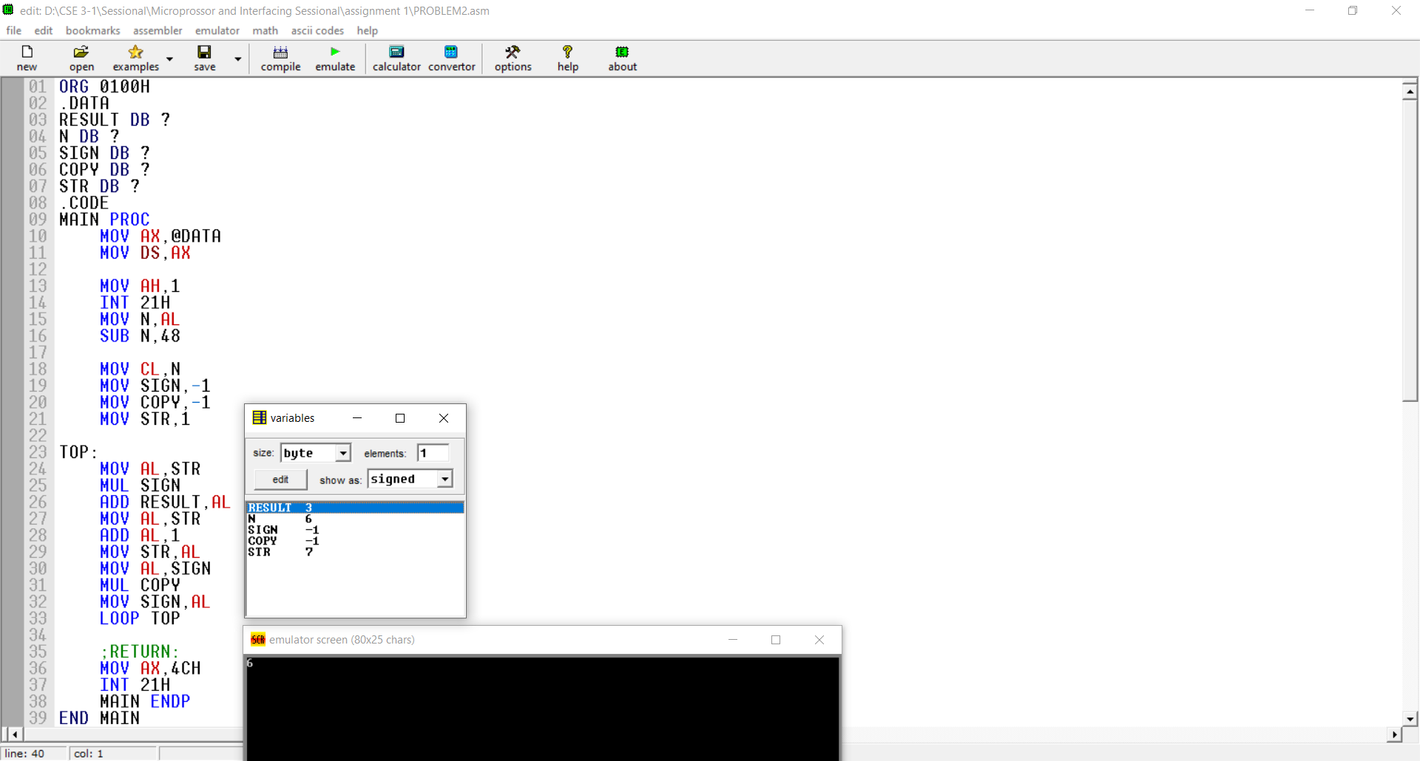

**Problem 3:**

ORG 0100H

.DATA

N DW ?

AA DW 'A+$'

A DW 'A$'

B DW 'B$'

C DW 'C$'

D DW 'D$'

F DW 'F$'

MSG DW 'GRADE: $'

.CODE

MAIN PROC

MOV AX,@DATA

MOV DS,AX

;FAST BX=0

XOR BX,BX

INPUT_LOOP:

;CHAR INPUT

MOV AH,1

INT 21H

;IF\N\R,STOP TAKING INPUT

CMP AL,10

JE END_INPUT_LOOP

CMP AL,13

JE END_INPUT_LOOP

;FAST CHAR TO DIGIT

;ALSO CLEARS AH

AND AX,000FH

;SAVE AX

MOV CX,AX

;BX=BX*10+AX

MOV AX,10

MUL BX

ADD AX,CX

MOV BX,AX

JMP INPUT_LOOP

END_INPUT_LOOP:

MOV N,BX

;NEW LINE

MOV AH,2

MOV DL,0AH

INT 21H

MOV DL,0DH

INT 21H

;OUTPUT

MOV AH,9

LEA DX,MSG

INT 21H

;COMPARE

CMP BX,90

JL GA

LEA DX,AA

JMP RETURN

GA:

CMP BX,80

JL GB

LEA DX,A

JMP RETURN

GB:

CMP BX,70

JL GC

LEA DX,B

JMP RETURN

GC:

CMP BX,60

JL GD

LEA DX,C

JMP RETURN

GD:

CMP BX,50

JL GF

LEA DX,D

JMP RETURN

GF:

LEA DX,F

RETURN:

MOV AH,9

INT 21H

MOV AX,4CH

INT 21H

MAIN ENDP

END MAIN

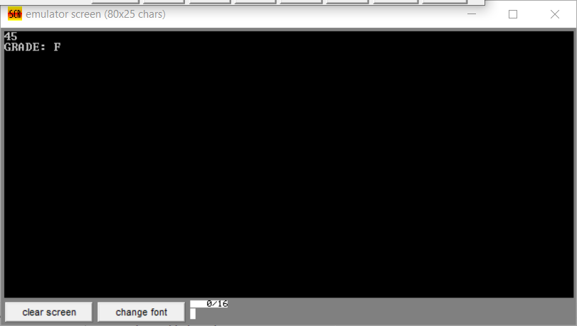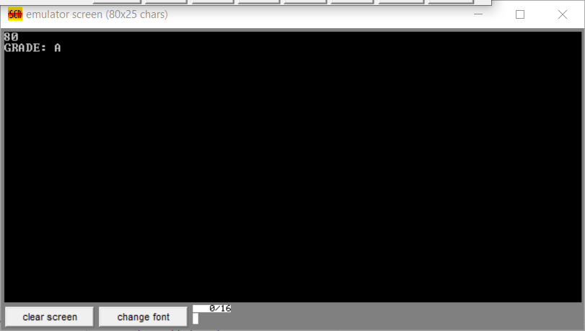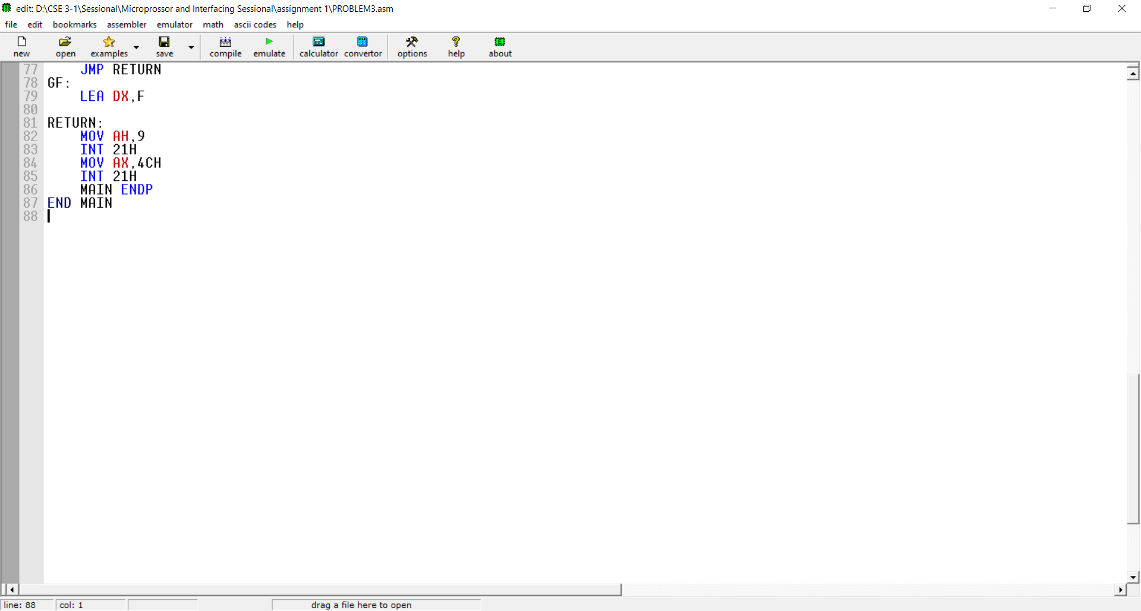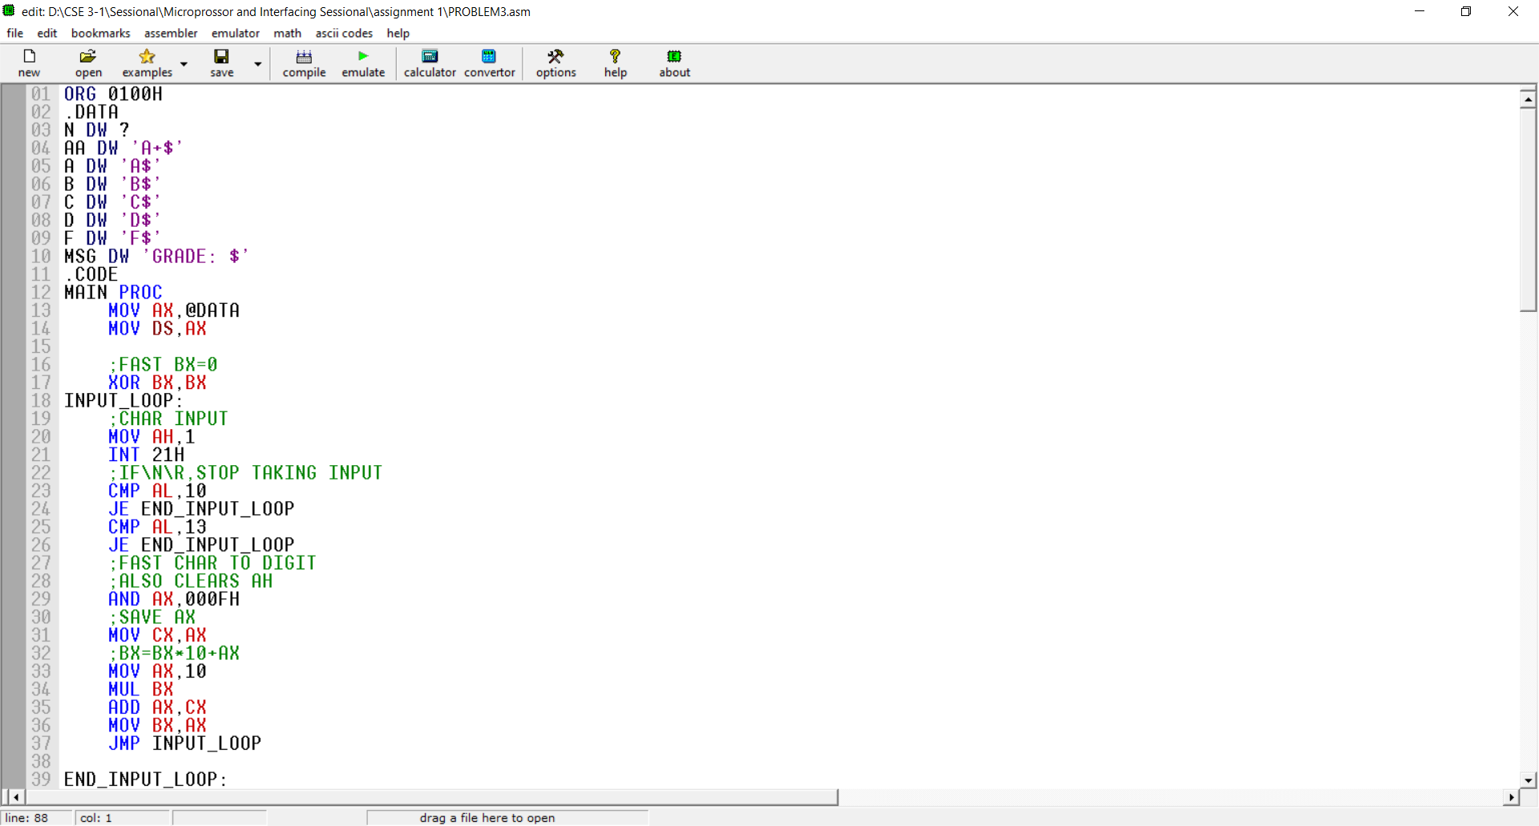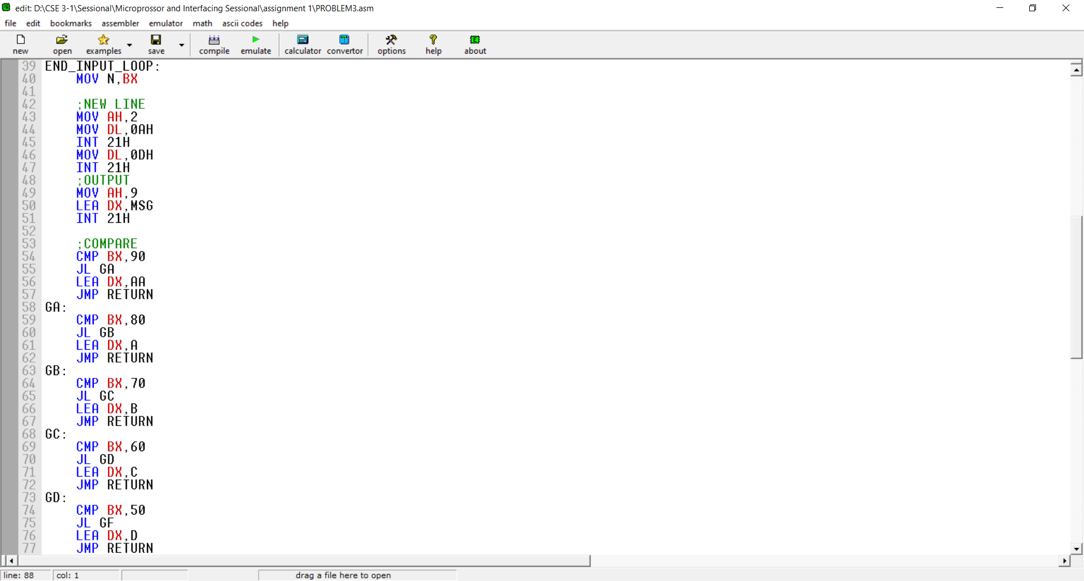

**Discussion:**

Finally, it can be said that we learned so many things. The most important thing is that we can now take input more than 9. That means we are able to input multiple digit at a time and when the input digit is completely entered than stop the input process to press enter.